Unit 5-Embedded System

Definition:
An Embedded System is a system that has software embedded in computer hardware. It is designed to perform a dedicated function. Sometimes, it may be designed to perform a set of few tasks.
An embedded system mainly consists of hardware, OS, memory, peripherals (I/O devices) and interfaces for performing the set of dedicated tasks. The embedded software is called “firmware”.
 A few embedded systems do not contain OS.
 A few embedded systems do not use any interfaces.

Features Embedded System
- It consists of application specific hardware and OS to perform one or a few tasks.
2.Needs lesser memory.
3.It uses few peripherals.
4.Lesser or no user interfaces.
5.It cannot be reprogramed by the end-user, except in a few cases.
6.Stringent time constraints.
7.Smaller in size and less expensive.
8.Relatively less power.

APPLICATIONS OF EMBEDDED SYSTEMS
1. Domain: Consumer Electronics
Applications: Digital cameras, digital wrist watches and DVD player
2. Domain: Household (Domestic) appliances
Applications: Washing machine, microwave oven, TV and refrigerator
3. Domain: Home automation
Applications: Automatic door locks (in home, buses and trains), automatic blinds,
4. Domain: Security systems
Applications: CCTV cameras, and fire alarms in home and industry.
5. Domain: Automotive industry
Applications: Airbag, anti-lock braking system (ABS) and other systems used for
entertainment and safety.
6. Domain: Telecommunication
Applications: Mobile phones and multimedia applications.
7. Domain: Computer Peripherals
Applications: Printers, keyboards, keypads, LCD display, optical mouses, scanners
and fax machines.
8. Domain: Computer networking systems
Applications: Network switches, routers, hubs and firewalls.
9. Domain: Health care
Applications: Different kinds of scanners, EEG and ECG machines.
10. Domain: Measurement & Instrumentation
Applications: Digital multimeters, digital CROs and logic analysers.
11. Domain: Banking & Finance
Applications: Automatic Teller Machines (ATMs), currency counters and points of
sales (POS).
12. Domain: Card Readers
Applications: Barcode readers and smart card readers

CHARACTERISTICS OF EMBEDDED SYSTEMS
Each ES has a set of specific and unique characteristics. Some of the important characteristics of ESs are: -
1. Application and Domain specific
2. Reactive and Real Time
3. Operates in harsh environments
4. Distributed
5. Small size and weight
6. Power Concerns
1. Application and Domain specific:
Each ES is designed to perform one or few unique functions. It cannot be used for any other purpose.
For example: You cannot replace embedded control system
✓ For a microwave oven by that of a washing machine.
✓ For a Telecom domain with that of a consumer electronics domain.
2. Reactive and Real Time:
ESs continuously interact with the Real world through sensors, control algorithms and input devices at the input port of the system. So, they are also called reactive systems.
An ES produces changes in output response to the changes in the input variables. It is
designed with proper response time for each task. It should not miss the deadline for any task. Any change in the real world is called event.
An event may be a periodic event or unpredicted event. There is no problem with periodic events. They are well identified and handled. The important thing is an ES should not miss unpredicted events. The design of such systems should take worst-case situations into consideration.
Note: Some ESs may not be real time in operation. (e.g., electronic toys).
3. Operates in harsh environments:
Sometimes ESs may be installed in harsh environments. Such systems must be capable to withstand all the adverse conditions. The design should take care of operating conditions of the area where it is installed.
Example 1: ESs in high temperature zone
All the components used in the system should be of high temperature grade. Here we cannot go for compromise in cost.
Example 2: ESs in vibrations and shock environment
Proper shock absorption techniques should be provided.
Other examples for harsh environments: Power supply fluctuations, corrosion, component aging, etc.
4. Distributed
Sometimes many distributed ESs may form a single large ES. All of them are independent embedded units. But they work together to perform the specified function.
Example 1: Automatic chocolate vending machine (ACVM) contains a user keypad, coin counting module, and chocolate dispensing mechanism. Each of them is an individual ES. All of them work together to perform overall vending function
Example 2: an Automatic Teller Machine (ATM) contains a card reader for reading and validating ATM card, cash dispensers, receipt printers and LCD Display units.
All the units are individual ESs. But they work together to achieve a common goal.
5. Small size and weight:
Generally, a user gives much importance to product aesthetics (size, weight, shape, style, etc.) in choosing a product. (e.g., Mobile phone)
Many users like small devices. It is not just their like. A small, less weighted and compact (occupying less space) device is always convenient to handle than a bulky one. Same is the situation in embedded domain also.
6. Power Concern:
Power consumption: Power consumption is the amount of energy used per unit time. This implies that ESs should have low power consumption. This can be achieved by using the ultra-low power consuming components available in the market.
Also, battery life of portable systems (e.g., Cell phones and laptop computers) is limited by power consumption.
Power dissipation: An ES with large power dissipation needs cooling fans, which occupy additional space and make the system bulky. So ESs should have low power dissipation. To achieve this, ESs are designed using regulators with low dropout and processors / controllers with power saving mode.

Challenges of Embedded Systems

1. Resource Constraints
Limited Processing Power: Embedded systems often operate with limited processing capabilities, requiring efficient use of available resources.
Memory Limitations: Constrained memory (RAM and non-volatile storage) necessitates careful management and optimization of software.

2. Energy Consumption
Energy Efficiency: Many embedded systems are battery-operated or have strict power consumption requirements, making energy efficiency a critical concern. Designing effective power management strategies to balance performance and power usage is challenging.

3. Real-Time Performance
Deterministic Responses and Latency: Ensuring real-time operation with deterministic responses to inputs is crucial in many embedded applications, such as automotive safety systems and industrial control. Minimizing latency and ensuring timely execution of tasks can be difficult in resource-constrained environments.

4. Security
Data Protection and Vulnerabilities: Embedded systems can be susceptible to security vulnerabilities, especially in connected devices as part of the Internet of Things (IoT). Ensuring the security of data and communication channels is a significant challenge.

5. Complexity of Development
Hardware-Software Integration: Integrating hardware and software components seamlessly is complex and requires a deep understanding of both domains.
Debugging: Debugging embedded systems can be challenging due to limited visibility into the system’s internal state and the use of specialized tools.

6. Testing and Reliability
Comprehensive Testing: Testing of functional and nonfunctional requirements comprehensively is required to identify and fix issues, but it can be time-consuming and resource-intensive.
Long-Term Reliability: Ensuring the long-term reliability of embedded systems, especially in critical applications like healthcare and aerospace, is essential.

7. Scalability and Flexibility
Scalability: Designing embedded systems that can scale to different applications and requirements without significant redesign is challenging.
Flexibility: Balancing the need for flexibility and customization with the constraints of embedded system design is a complex task.

Types of Processors
Processors can be of the following categories −
General Purpose Processor (GPP)

  - Microprocessor
  - Microcontroller
  - Embedded Processor
  - Digital Signal Processor
  - Media Processor

Application Specific System Processor (ASSP)

Application Specific Instruction Processors (ASIPs)

GPP core(s) or ASIP core(s) on either an Application Specific Integrated Circuit (ASIC) or a Very Large Scale Integration (VLSI) circuit.

1. General Purpose Processors (GPPs)
General purpose processors, also known as central processing units (CPUs), are processors that are designed to be capable of executing a wide range of tasks. They are used in computers and other devices that require high-performance processing capabilities. Some features of general-purpose processors include:
- Instruction set: General purpose processors have a large and complex instruction set, which allows them to perform a wide range of tasks.
- Multi-core: Many general-purpose processors are multi-core, which means they have multiple processors on a single chip. This allows them to perform multiple tasks concurrently, improving performance.
- Clock speed: The clock speed of a processor determines how fast it can execute instructions. General-purpose processors typically have high clock speeds, which allows them to perform tasks quickly.
- Cache: General-purpose processors have one or more levels of cache, which is a small amount of high-speed memory that is used to store frequently accessed data. This helps to improve the performance of the processor.
- Compatibility: General-purpose processors are typically compatible with a wide range of operating systems and software applications.
- Virtualization: Many general-purpose processors support virtualization, which allows them to run multiple virtual machines on a single physical machine.
- Power consumption: General-purpose processors can have high power consumption, which can be a concern in devices where power is limited.

2. Microprocessors
A microprocessor is a processor that is contained on a microchip, or integrated circuit (IC). It is a central processing unit (CPU) that executes the instructions of a computer program. Some features of microprocessors include:
- Instruction set: Microprocessors have a specific instruction set that defines the operations that they can perform.
- Clock speed: The clock speed of a microprocessor determines how fast it can execute instructions. Microprocessors typically have high clock speeds, which allows them to perform tasks quickly.
- Data bus: The data bus is a communication pathway that is used to transfer data between the microprocessor and other components in a system.
- Address bus: The address bus is a communication pathway that is used to transfer the address of a memory location between the microprocessor and other components in a system.
- Cache: Many microprocessors have one or more levels of cache, which is a small amount of high-speed memory that is used to store frequently accessed data. This helps to improve the performance of the microprocessor.
- Power consumption: Microprocessors can have relatively high power consumption, which can be a concern in devices where power is limited.
- Size: Microprocessors are designed to be small, as they are typically used in devices where space is at a premium.
- Cost: Microprocessors can vary in cost depending on their capabilities and features.

3. Microcontrollers
A microcontroller is a small, low-power computer that is contained in a single integrated circuit (IC). It is a type of embedded processor that is used in a wide range of devices, including consumer electronics, industrial control systems, and automotive systems. Some features of microcontrollers include:
- On-chip peripherals: Many microcontrollers have a variety of on-chip peripherals, such as timers, serial ports, and analog-to-digital converters, which allow them to interface with external devices.
- Memory: Microcontrollers have both program memory, which stores the instructions that are executed by the processor, and data memory, which is used to store variables and other data.
- Input/output (I/O) pins: Microcontrollers have a set of I/O pins that can be used to interface with external devices, such as sensors or actuators.
- Low power consumption: Microcontrollers are designed to be low-power, which makes them suitable for use in battery-powered devices.
- Cost: Microcontrollers are typically less expensive than general-purpose processors, as they are designed for specific tasks and do not have as many capabilities.
- Size: Microcontrollers are small, which makes them suitable for use in compact devices.
- Flexibility: Microcontrollers are highly flexible and can be programmed to perform a wide range of tasks.

4. Digital Signal Processor (DSP)
Digital signal processors (DSPs) are specialized microprocessors that are designed to process digital signals. They are used in a wide range of applications, including audio and video processing, telecommunications, and control systems. Some key features of DSPs include:
- High-speed processing: DSPs are designed to process large amounts of data quickly, making them well-suited for real-time applications.
- Parallel processing: Many DSPs are designed to perform multiple operations simultaneously, which can increase their processing speed and efficiency.
- Hardware support for common operations: DSPs often include specialized hardware to support common operations, such as filtering and FFTs (Fast Fourier Transforms), which can reduce the processing overhead and improve performance.
- Low power consumption: DSPs are often designed to be energy-efficient, making them well-suited for battery-powered applications.
- Programmability: Most DSPs are programmable, which means that they can be customized to perform specific tasks. This allows them to be used in a wide range of applications.

5. Single-Purpose Embedded Processor
Single-purpose embedded processors, also known as application-specific embedded processors, are microprocessors that are designed to perform a specific task or set of tasks. They are used in a wide range of applications, including automotive systems, industrial control systems, and consumer electronics. Some key features of single-purpose embedded processors include:
- Specialized functionality: Single-purpose embedded processors are designed to perform a specific task or set of tasks, making them well-suited for applications that require highly specialized functionality.
- Low power consumption: Single-purpose embedded processors are often designed to be energy-efficient, making them well-suited for battery-powered applications.
- Compact size: Single-purpose embedded processors are often designed to be small and lightweight, making them well-suited for applications where space is limited.
- High reliability: Single-purpose embedded processors are often designed to be highly reliable, as they are typically used in mission-critical applications where downtime is not an option.
- Low cost: Single-purpose embedded processors are often less expensive than general-purpose processors, as they are designed to perform a specific set of tasks and do not require the same level of flexibility and programmability.

6. System-on-Chip (SoC)
System-on-Chip (SoC) is an integrated circuit that integrates all components of a computer or other electronic system onto a single chip. Some key features of SoCs include:
- Integration: SoCs integrate all or most of the components of a system onto a single chip, which can reduce the size and complexity of the system.
- Low power consumption: SoCs can be designed to be highly power efficient, which can be useful in battery-powered or energy-sensitive applications.
- High performance: SoCs can be designed for high performance, making them suitable for applications that require a lot of processing power.
- Customization: SoCs can be customized for specific applications, allowing them to be optimized for the specific requirements of those applications.
- Reduced component count: Because many components are integrated onto a single chip, SoCs can reduce the component count of a system, which can make the system simpler and easier to manufacture.

EMBEDDED SYSTEM HARDWARE
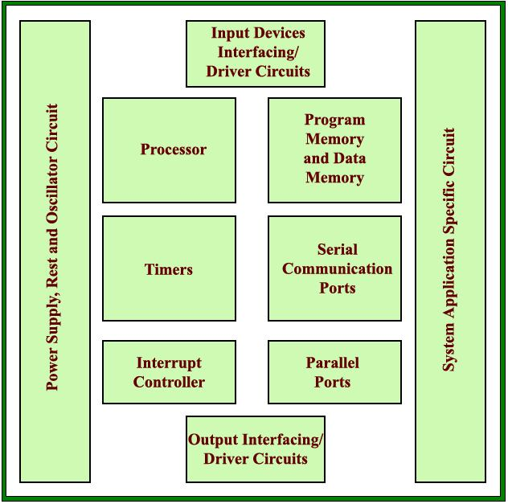
COMPUTER HARDWARE
A Microprocessor
A Large Memory
(Primary and Secondary)
(RAM, ROM and caches)
Input Units
(Keyboard, Mouse, Scanner, etc.)
Output Units
(Monitor, printer, etc.)
Networking Units
(Ethernet Card, Drivers, etc.)
I/O Units
(Modem, Fax cum Modem, etc.)
COMPONENTS OF EMBEDDED SYSTEM
• It has Hardware
Processor, Timers, Interrupt controller, I/O Devices, Memories, Ports,
etc.
• It has main Application Software
Which may perform concurrently the series of tasks or multiple tasks.
• It has Real Time Operating System (RTOS)
RTOS defines the way the system work. Which supervise the application
software. It sets the rules during the execution of the application
program. A small scale embedded system may not need an RTOS.

Real-Time Operating System (RTOS) based Embedded System Design
Understand the basics of an operating system and the need for an operating system

OPERATING SYSTEM BASICS The operating system acts as a bridge between the user applications/tasks and the underlying system resources through a set of system functionalities and services. The OS manages the system resources and makes them available to the user applications/tasks on a need basis. A normal computing system is a collection of different I/O subsystems, working, and storage memory. The primary functions of an operating system is • Make the system convenient to use • Organise and manage the system resources efficiently and correctly
Fig gives an insight into the basic components of an operating system and their interfaces with rest of the world.

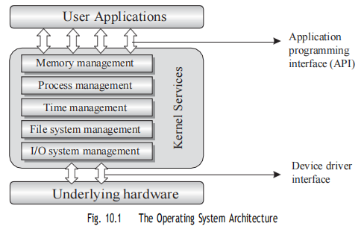
Real-Time Operating System (RTOS) There is no universal definition available for the term ‘Real-Time’when it is used in conjunction with operating systems. What ‘Real-Time’ means in Operating System context is still a debatable topic and there are many definitions available. In a broad sense, ‘Real-Time’ implies deterministic timing behaviour. Deterministic timing behaviour in RTOS context means the OS services consumes only known and expected amounts of time regardless the number of services. A Real-Time Operating System or RTOS implements policies and rules concerning time-critical allocation of a system’sresources. The RTOS decides which applications should run in which order and how much time needs to be allocated for each application. Predictable performance is the hallmark of a well-designed RTOS. This is best achieved by the consistent application of policies and rules. Policies guide the design of an RTOS. Rules implement those policies and resolve policy conflicts.
Windows Embedded Compact, QNX, VxWorks MicroC/OS-II etc are examples of Real Time Operating Systems (RTOS).

